
National College of Computer Studies
Paknajol, Kathmandu

Report on Grocery Management System

Submitted by: Suraj Timsina Submitted to:
Programme: BSc. CSIT, 4th Semester Sumit Ghising
Section: B
Roll No: 22
Email: surajtimsina321@gmail.com
Declaration
I hereby declare that the project work entitled “Grocery Management System” submitted to Institute of Science and Technology, Tribhuvan University, Kathmandu. National College of Computer Studies, Kathmandu, is for the degree is submitted in partial fulfillment of requirements for the degree of Bachelor of Science in Computer Science and Information Technology (BSc.CSIT). This report contains all the original research and analysis with some information taken from other resources which are properly cited. This project work has not been submitted to any other university or institution for the award of any degree or diploma.

……………………
Suraj Timsina
Date: January 2025

Acknowledgement
This report is my assignment as a partial fulfillment of the project work course for the requirement of Bachelor of Science in Computer Science and Information Technology (BSc.CSIT). I would like to take this opportunity to express my sincere gratitude to my respected teacher, Mr. Sumit Ghising, for his invaluable guidance and support throughout the development of this project. His constant encouragement and insightful advice played a crucial role in bringing this project to fruition.
I would also like to extend my heartfelt thanks to all my teachers at National College of Computer Studies for their continuous guidance, feedback, and support during the course of this project. The project has been completed under the intensive and genuine guidance of National College of Computer Studies, and I am truly grateful for their contributions to my academic and professional growth.

Suraj Timsina
National College of Computer Studies
Date: January 2025

Abstract
The Grocery Management System is a comprehensive software solution designed to streamline and enhance the operational efficiency of grocery management processes. The system supports multiple roles, including administrators, users, and guests, providing tailored access and functionality for each.
The primary features include secure user authentication, robust product management, efficient order handling, and detailed user profile management. Built using Java and MySQL, the system leverages JDBC for database connectivity, ensuring seamless interaction with a relational database. With its modular design and role-based access control, the system caters to both administrative and customer-centric tasks, fostering a user-friendly and secure environment.
This documentation details the system’s architecture, functionality, database schema, and operational workflows, highlighting its potential to optimize grocery management for small to medium-sized businesses. Future enhancements, such as integration with payment gateways and advanced search capabilities, will further elevate the platform's utility and scalability.

Table of Contents
1. INTRODUCTION 1
1.1. PURPOSE 1
1.2. OBJECTIVE 2
2. TOOLS & TECHNOLOGY 3
3. LITERATURE REVIEW 4
4. SYSTEM FEATURES 4
4.1 Roles & Responsibilities 4
1. Administrator 4
2. User 5
3. Guest 5
4.2 Functionalities 5
5. METHODOLOGY 6
6. SYSTEM DESIGN 6
7. DATABASE DESIGN 7
8. EXPECTED OUTCOME 9
9. SYSTEM IMPLEMENTATION 9
9.1 The Hardware used 9
9.2 The Software used 9
9.3 MY SOURCE CODE 10
9.4 OUTPUT 17
10. LIMITATION 20
11. CONCLUSION 21
References 22

List of Figures
Figure 1: Main Function 1 10
Figure 2: Main Function 2 11
Figure 3: Method for read password 12
Figure 4: Method for Authentication 12
Figure 5: Admin Panel 13
Figure 6: Method for manage users 13
Figure 7: Method for view users 14
Figure 8: User Panel 14
Figure 9: Method for place order 15
Figure 10: Guest Panel 15
Figure 11: Method for update product 16
Figure 12: Method for view order 16
Figure 13: Adding User in Admin Panel 17
Figure 14: User List 18
Figure 15: Product List 18
Figure 16: User Panel Output 19
Figure 17: Ordering Product 19
Figure 18: Guest Panel Output 20

List of Tables
Table 1: Users Database Table 8
Table 2: Products Database Table 8
Table 3: Order Database Table 8
Table 4: Order_items Database Table 8

INTRODUCTION
The Grocery Management System is a modern, innovative software solution designed to address the growing needs of grocery stores in managing their daily operations efficiently. As grocery businesses expand and customer demands grow, managing inventory, user roles, and customer orders becomes increasingly challenging. This system provides a centralized and automated platform to simplify these processes, thereby reducing manual efforts, minimizing errors, and enhancing productivity. [1]
The system incorporates a multi-role architecture, catering to different types of users such as administrators, customers, and guests. Each role is equipped with specific functionalities, ensuring that the system is both secure and user-friendly. Administrators can oversee inventory management, user data, and orders, while customers can browse products, place orders, and manage their profiles. Guests can explore the product catalog, encouraging potential customers to interact with the platform.
Built using Java as the core programming language, the system is designed to offer cross-platform compatibility and robustness. The integration of a MySQL database ensures reliable and efficient storage of critical data, including user information, product details, and transaction records. Java Database Connectivity (JDBC) acts as the bridge between the application and the database, enabling seamless data exchange.
The system also emphasizes security by incorporating role-based authentication and database query handling through prepared statements. This ensures that sensitive user information and business data remain protected from unauthorized access and SQL injection attacks.
In addition to its core functionalities, the Grocery Management System is highly scalable and can be easily adapted to the specific requirements of different businesses. It is suitable for small and medium-sized enterprises, providing them with the tools to compete in the digital age. By leveraging technology, this system helps businesses save time, reduce costs, and improve customer satisfaction.

PURPOSE
The Grocery Management System is designed to streamline the operations of grocery stores by providing a unified platform for managing users, products, and orders. The system addresses the challenges of traditional manual processes, offering automation and efficiency to modernize grocery store operations. By integrating essential functionalities into a single platform, the system reduces administrative burden, minimizes errors, and ensures a seamless experience for both staff and customers. [2]

Key purposes of the system include:
- Simplifying User Management
- Efficient Inventory Management
- Seamless Order Processing
- Enhancing User Experience

OBJECTIVE
The Grocery Management System aims to provide a comprehensive and user-friendly platform for managing grocery store operations. The primary objectives of the system include:
1. Streamline Grocery Management Processes
- Automate repetitive tasks such as inventory updates, order tracking, and user management to reduce manual efforts and errors.
2. Enhance Operational Efficiency
- Provide tools for administrators to effectively manage products, users, and orders, ensuring smooth day-to-day operations.
3. Ensure Data Security and Access Control
- Implement role-based authentication to restrict access to sensitive data and functionalities based on user roles (Administrator, User, Guest).
4. Facilitate Product and Order Management
- Allow administrators to perform CRUD operations on product data, ensuring accurate inventory tracking.
- Enable users to browse products, place orders, and view their order history conveniently.
5. Provide a User-Friendly Interface
- Design intuitive and easy-to-navigate panels for different roles (Administrator, User, Guest), enhancing the overall user experience.
6. Enable Scalability and Adaptability
- Ensure that the system is scalable and can accommodate the growing needs of a business, such as adding new features or expanding to larger databases.
7. Promote Business Growth and Customer Satisfaction
- Offer customers a seamless experience by providing a platform to browse products, place orders, and manage profiles effortlessly.
- Help businesses gain customer trust by improving operational reliability and responsiveness.
8. Minimize Operational Costs
- By automating key processes, the system reduces reliance on manual labor, minimizing operational costs and increasing profitability.

TOOLS & TECHNOLOGY
To fulfill its purpose, the system utilizes a combination of powerful technologies and tools:
1. Programming Language: Java
- Java serves as the backbone of the application, providing a platform-independent, secure, and object-oriented programming environment.
- Its robustness ensures reliability, while its extensive libraries support efficient application development.
2. Database: MySQL
- MySQL is employed as the relational database for storing and managing structured data.
- It provides scalability, supports ACID properties for data integrity, and ensures efficient query handling for user, product, and order information.
3. Connectivity: JDBC (Java Database Connectivity)
- JDBC acts as the middleware between the application and the MySQL database, facilitating secure and efficient database communication.
- Prepared statements and transactions are utilized to ensure data security and consistency during operations.
4. Integrated Development Environment: Visual Studio Code (VS Code)
- Why VS Code?
  - VS Code is a lightweight, versatile, and feature-rich IDE that supports multiple languages and frameworks, including Java.
  - Its extensibility through plugins, such as the Java Extension Pack, provides developers with tools for code completion, debugging, and syntax highlighting.

- Features Utilized:
  - Debugging Tools: Simplified the testing and troubleshooting of Java code, ensuring error-free execution.
  - Extensions: Used plugins like MySQL Database Explorer to directly interact with the database.
  - Version Control Integration: Seamlessly integrated with Git for source code management and collaboration.
  - User Interface Customization: Enhanced productivity by configuring themes, keyboard shortcuts, and settings tailored to project requirements.

LITERATURE REVIEW
The Grocery Management System is designed to address challenges associated with managing groceries by leveraging modern technologies. To contextualize the project, it is essential to review existing grocery management systems, analyze methodologies and tools used in similar projects, and identify gaps and challenges in current systems.
Several grocery management systems are available in the market, ranging from small-scale applications to enterprise-level platforms. These systems typically offer functionalities such as inventory tracking, order processing, and customer management. [2]

SYSTEM FEATURES
The Grocery Management System incorporates a robust set of features designed to address the needs of different user roles, streamline grocery management, and provide a seamless user experience. The system supports three distinct roles, each with specific functionalities, and offers various tools to manage authentication, products, and orders efficiently.

Roles & Responsibilities

Administrator
- Role Overview:
The administrator oversees the system's operations, ensuring the smooth management of users, products, and orders.
- Key Responsibilities:
  - Manage Users: Add, view, and delete user accounts.
  - Manage Products: Perform CRUD (Create, Read, Update, Delete) operations on the product inventory.
  - Manage Orders: View all orders, delete orders, and track order statuses.
- Interface:
An intuitive Admin Panel with options for user, product, and order management.

User
- Role Overview:
Users are registered customers who can browse products, place orders, and manage their profiles.
- Key Responsibilities:
  - Browse and View Products: Explore the product catalog, including details like category, price, and availability.
  - Place Orders: Select products, specify quantity, and provide delivery details.
  - View Orders: Access order history and details, including payment status and total cost.
  - Manage Profile: View personal information such as name, email, phone number, and user type.
- Interface:
A User Panel designed for easy navigation and personalized access to order and profile management.

Guest
- Role Overview:
Guests are unregistered users who can browse the product catalog without making purchases.
- Key Responsibilities:
  - View Available Products: Explore the product list, encouraging potential registration for further access.
- Interface:
A simplified Guest Panel focused on product browsing.

Functionalities
- User Authentication (Role-Based Access)
- Role-based login system ensures secure access to the application.
- Credentials, including username and password, are validated against stored records in the database.
- Role-specific access restricts or grants functionalities, ensuring data security and compliance.
- Product Management (CRUD Operations)
- Create: Add new products to the inventory with details like name, category, price, and stock status.
- Read: View a list of available products, including product ID, name, price, and availability.
- Update: Modify product information such as price or availability status.
- Delete: Remove obsolete or unavailable products from the inventory.
- Order Management
- Place Orders: Users can select products, specify quantities, and provide delivery details. The system calculates the total cost and stores the order in the database.
- View Orders:
  - Administrators can view all orders, including order details and user information.
  - Users can view their own order history and details, such as payment status and delivery address.
- Delete Orders: Administrators can remove incorrect or outdated orders from the system.

METHODOLOGY
The development of the Grocery Management System followed a structured and systematic approach to ensure efficiency, reliability, and scalability. The chosen methodology combined Incremental Development with elements of the Agile Model, allowing for iterative improvements and continuous feedback integration.

SYSTEM DESIGN
The system is designed to handle different roles such as Admin, User, and Guest, each with distinct functionalities. The primary class in the system is GroceryManagementSystem, which orchestrates the flow of operations. This class interacts with various methods that handle the different user roles and perform CRUD operations on the database. The backend database design supports the system’s functionalities.
Class Overview:
- Main Class: GroceryManagementSystem
  - This class serves as the main controller of the system, managing interactions and invoking relevant methods for each user role.

Key Methods:
- adminPanel():
  - Responsible for providing access to the admin interface, allowing the admin to manage users, products, and orders.
  - Calls CRUD operations for managing users and products, and viewing orders.
- userPanel():
  - Manages the functionalities available to registered users, such as browsing products, placing orders, and viewing order history.
  - Calls methods to place orders, view available products, and manage the user profile.
- guestPanel():
  - Allows unregistered users (guests) to browse the product catalog but limits them from placing orders or managing a profile.
- CRUD Operations:
  - addUser(): Adds a new user to the database.
  - viewProducts(): Displays the list of products available in the system.
  - addProduct(): Adds a new product to the inventory.
  - updateProduct(): Updates product details such as price or stock status.
  - deleteProduct(): Removes a product from the inventory.
  - placeOrder(): Allows users to place an order by selecting products and specifying quantities.
  - viewOrders(): Allows users and admins to view order history and details.

DATABASE DESIGN
The database schema is designed to store information related to users, products, orders, and the items in each order.
Users Table
Attribute | Type | Index | Description
Id | INT(AUTO_INCREMENT) | Primary Key | User ID
Name | VARCHAR(100) | Not null | User Name
Phone_number | VARCHAR(12) | Not null | User Phone Number
Email | VARCHAR(100) | Not null | User Email
Password | VARCHAR(100) | Not null | User Password
User_type | ENUM('administrator', 'user') | Not null | User/Admin
Table 1: Users Database Table
Products Table
Attribute | Type | Index | Description
Id | INT(AUTO_INCREMENT) | Primary Key | Product ID
Name | VARCHAR(100) | Not null | Product Name
Category | VARCHAR(20) | Not null | Product Category
Price | INT | Not null | Product Price
Status | ENUM('in stock', 'out of stock') | Not null | In stock/out of stock
Table 2: Products Database Table
Orders Table
Attribute | Type | Index | Description
Id | INT(AUTO_INCREMENT) | Primary Key | Order ID
User_id | INT | Foreign Key | References user(id)
Total_price | INT | Not null | Total Price
Delivery_address | VARCHAR(255) | Not null | Delivery Address of order
Placed_on | TIMESTAMP | Not null | Date & Time of order
Payment_status | ENUM('Pending', 'Completed', 'Cancelled') | Not null | Pending/Completed/  Cancelled
Table 3: Order Database Table
Order_items Table
Attribute | Type | Index | Description
Order_id | INT | Foreign Key | References to orders(id)
Product_id | INT | Foreign Key | References to products(id)
Quantity | INT | Not null | Quantity of products
Price | INT | Not null | Price of products
- | {order_id, product_id} | Primary Key | -
Table 4: Order_items Database Table

EXPECTED OUTCOME
- User Authentication: Admin, user, and guest roles should function as expected with proper access control.
- CRUD Operations: Admin can successfully perform CRUD operations on users, products, and orders.
- Order Management: Users should be able to place, view, and manage their orders. Admin can track and delete orders.
- Database Integrity: Foreign key constraints should maintain data consistency, ensuring that related data is correctly linked.
- Performance: Indexes should improve query performance, especially for large datasets.
- Security: Passwords should be securely stored, and data validation should prevent incorrect inputs.

SYSTEM IMPLEMENTATION

The Hardware used
The implementation of the Grocery Management System using java can be done on any hardware that supports the java programming language, including personal computers, laptops, and servers.

The Software used
The software stack used to develop and implement the Grocery Management System includes:
- Programming Languages:
- Java: The entire system, both front-end and back-end, is developed using Java. Java is used for implementing the back-end logic, including business rules, user authentication, order management, and database connectivity via JDBC. It also manages the interactions between the user, products, and order data.
- Integrated Development Environments (IDEs):
- Visual Studio Code (VS Code): VS Code is used for writing and editing the Java code. It provides an efficient environment for Java development with extensions like Java Extension Pack for syntax highlighting, debugging, and compiling Java code.
- Database Management:
- MySQL: MySQL is used as the database management system for storing and handling all data related to users, products, orders, and transactions. It is integrated with Java via JDBC to perform CRUD operations.

- Other Tools:
- JDBC (Java Database Connectivity): JDBC is used to connect the system to the MySQL database, enabling it to interact with the database and perform operations like retrieving product details, updating order statuses, and managing user data.

MY SOURCE CODE
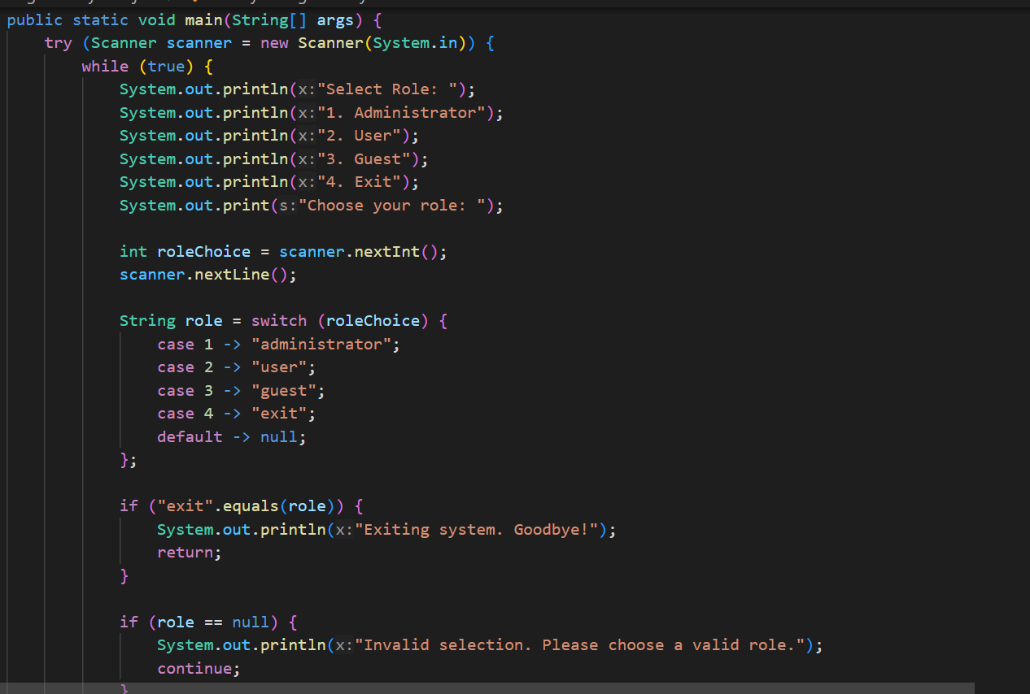
Figure 1: Main Function 1
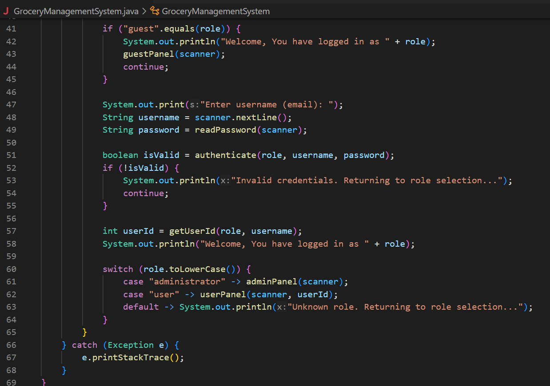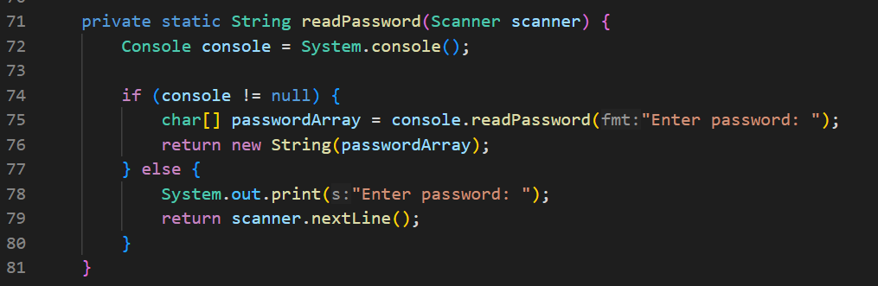
Figure 2: Main Function 2

Figure 3: Method for read password
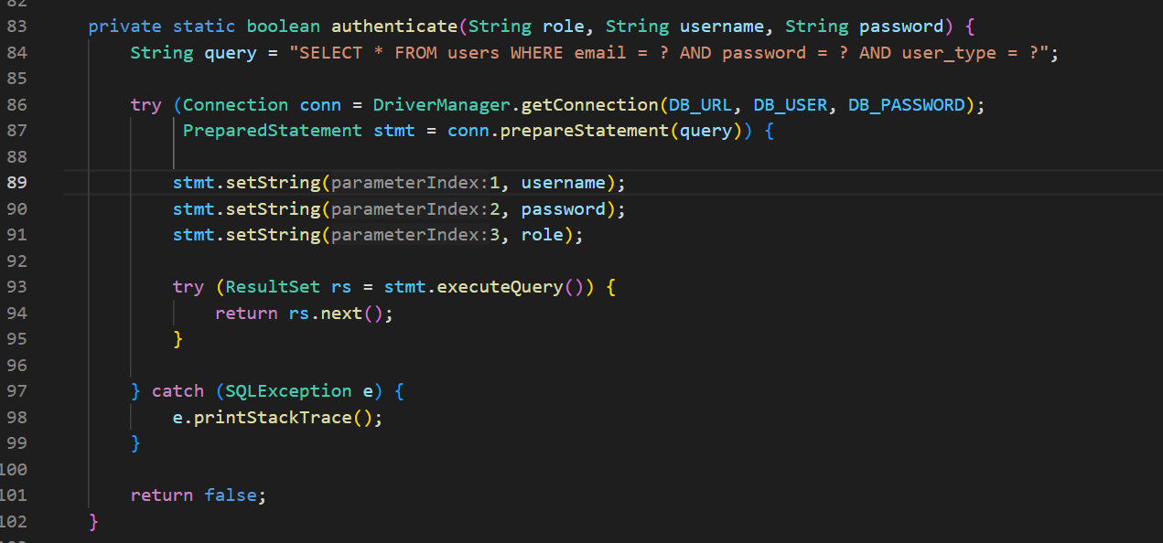
Figure 4: Method for Authentication

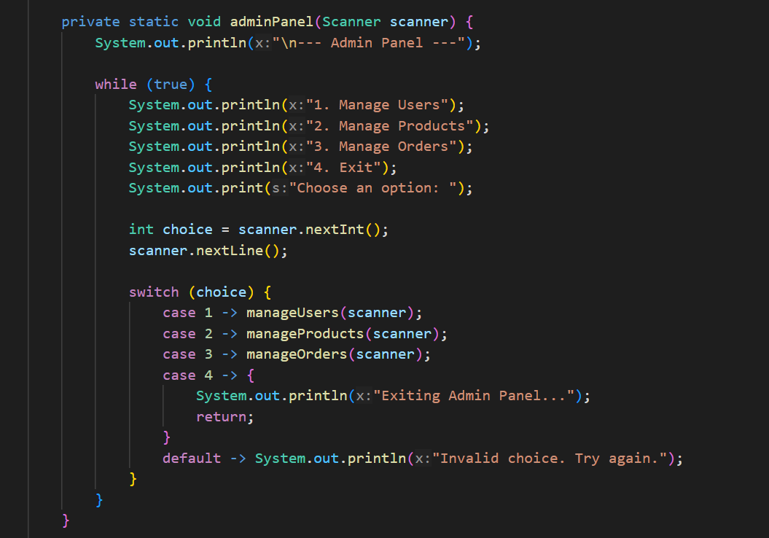
Figure 5: Admin Panel
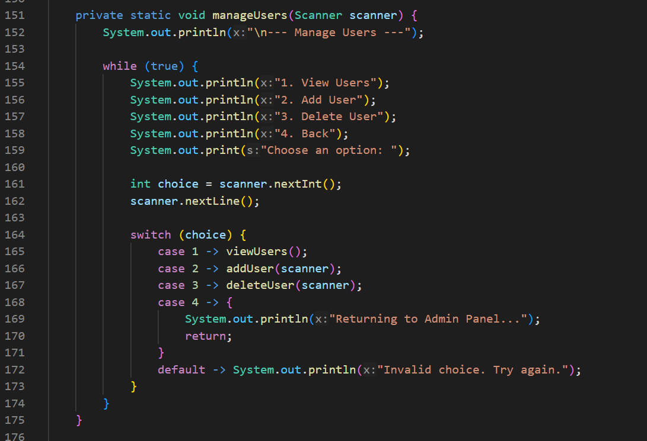
Figure 6: Method for manage users

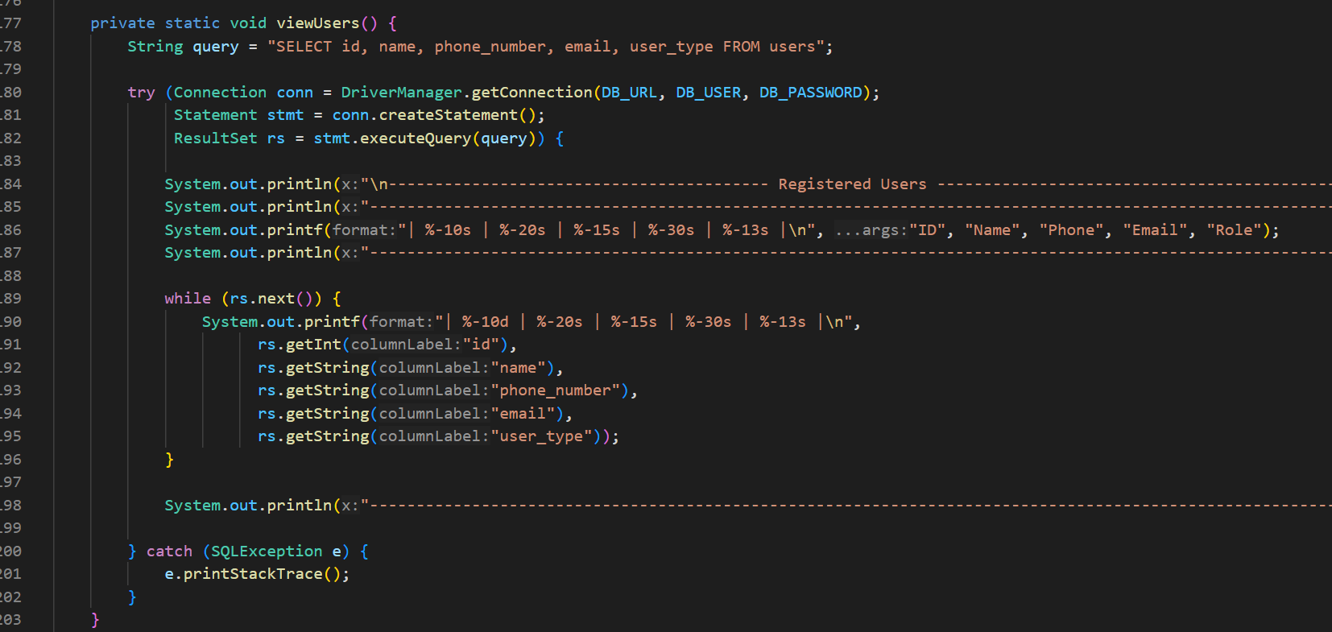
Figure 7: Method for view users
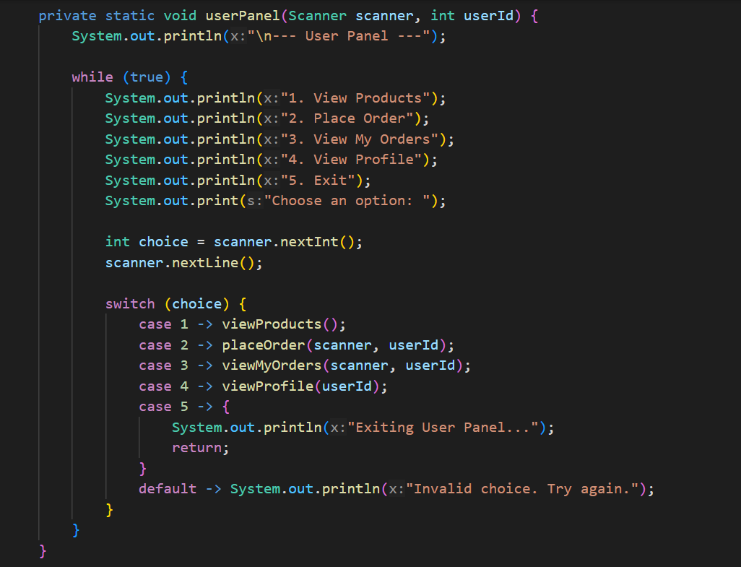
Figure 8: User Panel
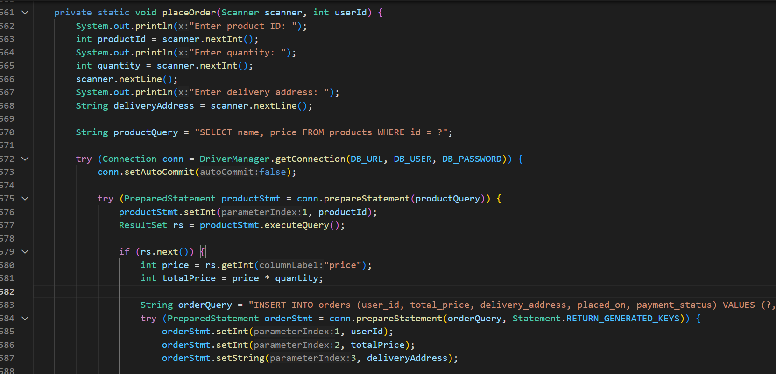
Figure 9: Method for place order

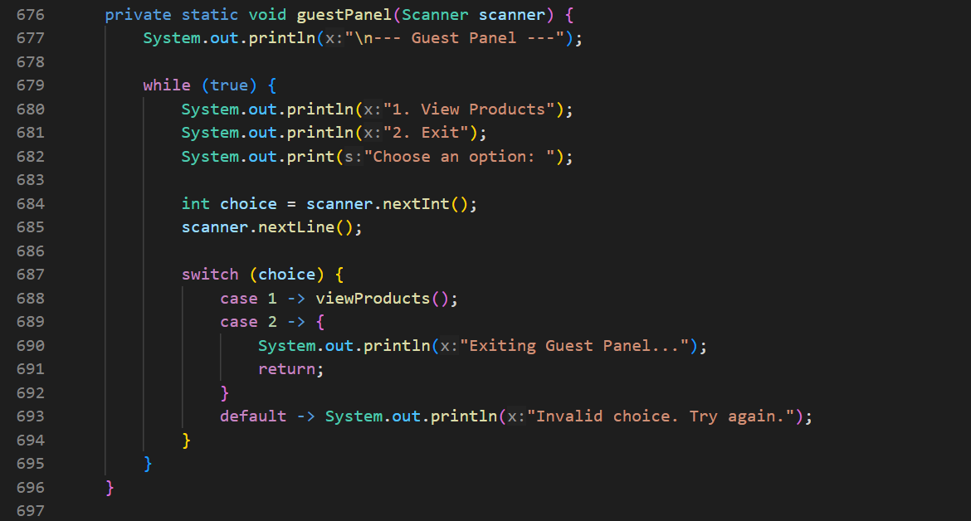

Figure 10: Guest Panel

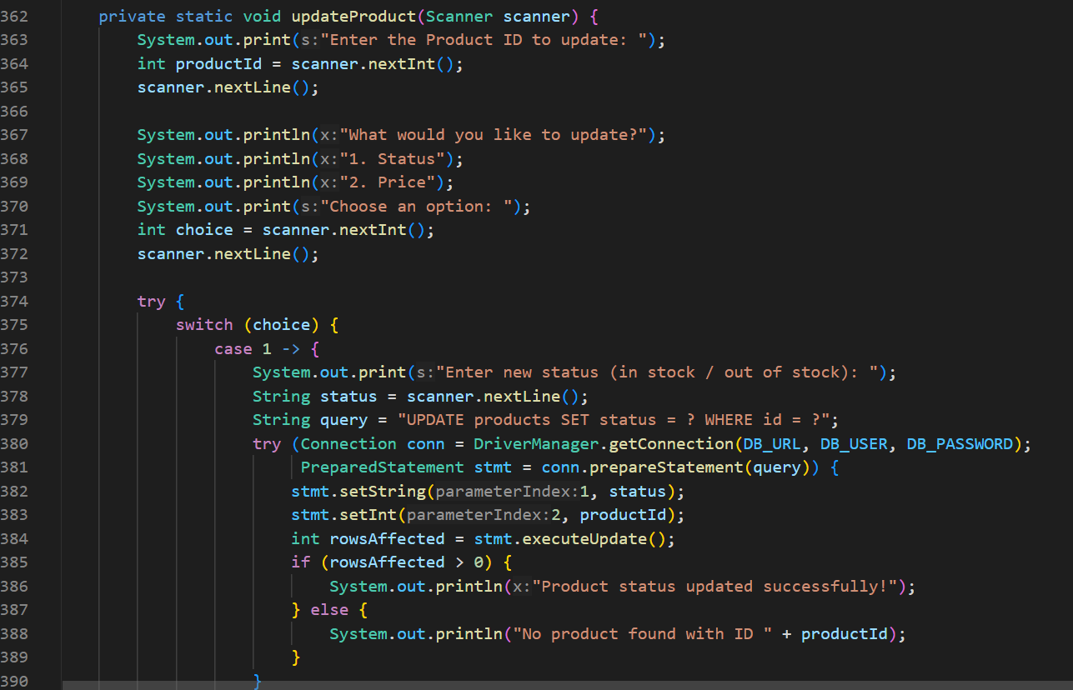
Figure 11: Method for update product

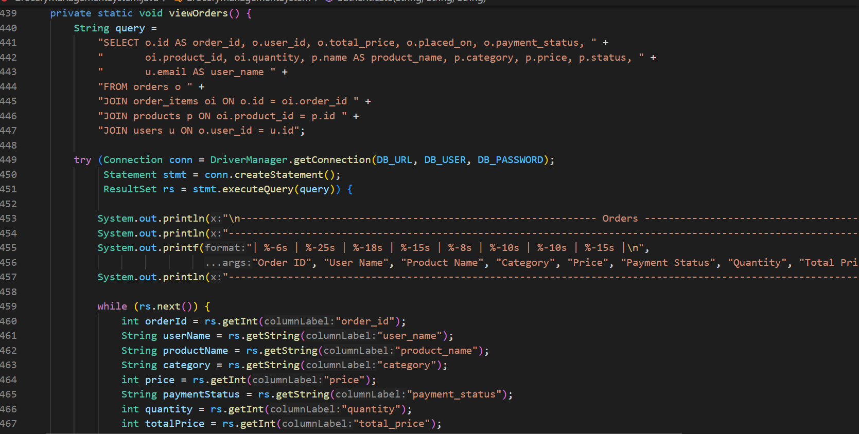
Figure 12: Method for view order

OUTPUT
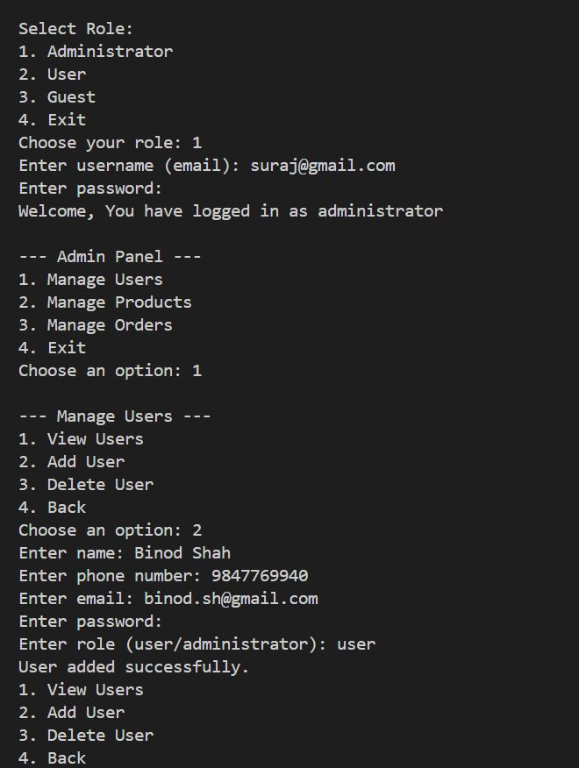
Figure 13: Adding User in Admin Panel

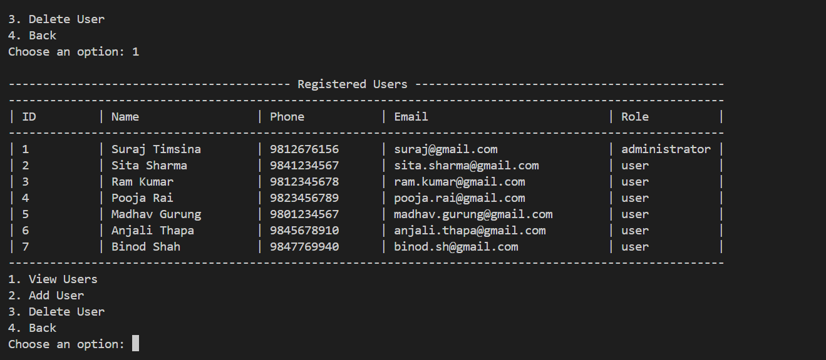
Figure 14: User List
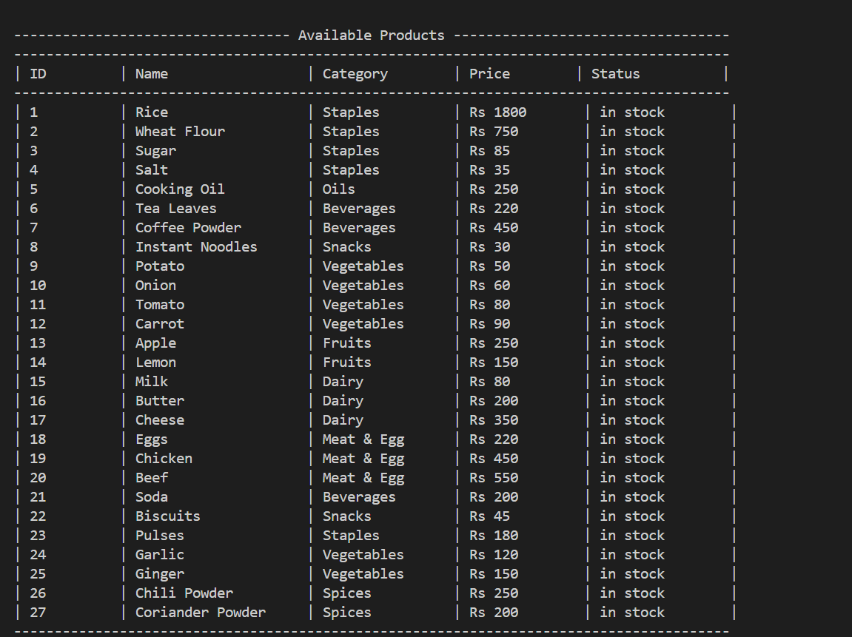
Figure 15: Product List

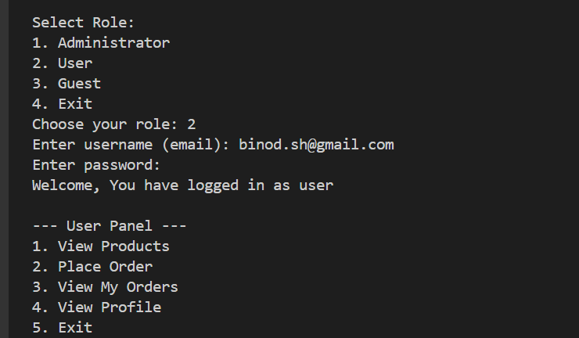
Figure 16: User Panel Output
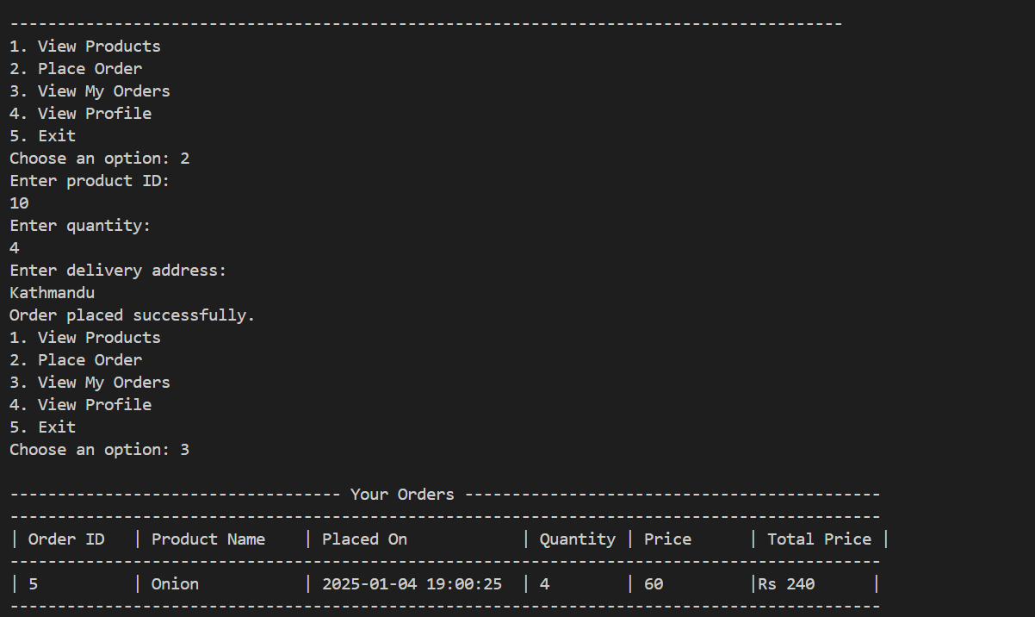
Figure 17: Ordering Product

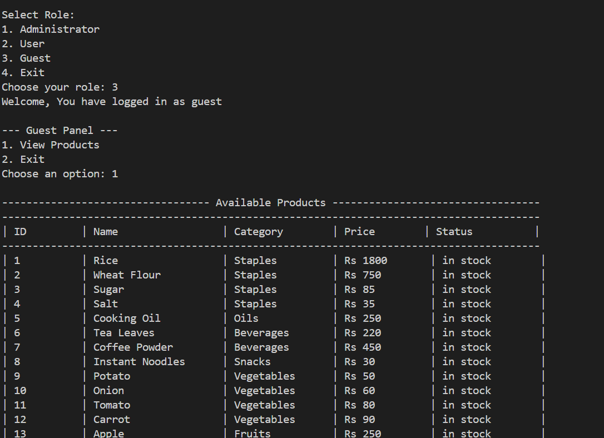
Figure 18: Guest Panel Output

LIMITATION
While the Grocery Management System effectively fulfills its primary objectives of managing users, products, and orders, it is not without limitations. These limitations stem from its basic design, focus on core functionality, and lack of advanced features. Understanding these constraints is essential for identifying areas for improvement and planning future enhancements. Below are the key limitations of the system:
- Role-Based Access Dependence
- Limited User Interface
- No Real-Time Notifications
- Lack of Advanced Security
- No Payment Gateway Integration

CONCLUSION
The Grocery Management System provides a robust and efficient solution for managing users, products, and orders in a streamlined manner. Its use of Java for back-end logic and MySQL for database management ensures reliability and ease of implementation. The system successfully meets its primary objectives by offering role-based access, product and order management, and a straightforward user interface.
However, like any system, it has limitations, including scalability constraints, basic security features, and limited reporting and notification capabilities. These constraints provide a foundation for future development, allowing for enhancements that can improve the system's functionality, user experience, and adaptability.
In conclusion, while the current implementation of the Grocery Management System is effective for small to medium-sized businesses, addressing its limitations will enable it to cater to larger enterprises and more complex requirements, ensuring long-term usability and success.

References

[1] | "https://www.slideshare.net/slideshow/final-project-report-on-grocery-store-management-system-pdf/269437782," [Online].
[2] | "https://www.fatbit.com/fab/grocery-inventory-management-software-detailed-overview/," [Online].

